CSA0501-DATABASE MANAGEMENT SYSTEMS
LAB EXPERIMENTS DATE: 14-07-2026

EXPERIMENT 5 -- SELECT with various clause – WHERE, pattern matching

AIM:
To view records from the tables using the SELECT statement with WHERE clause and LIKE operator.

PROCEDURE:
- Open MySQL Workbench and connect to the database.
- Select the required database using the USE command.
- Create and populate the required tables with sample data.
- Execute the SELECT statement with the WHERE clause to retrieve specific records.
- Use the LIKE operator with wildcard characters (% and _) for pattern matching.
- Verify the retrieved records after executing each query.
- Save the SQL queries and outputs.

PROGRAM:

1. List all Female Faculty
SELECT *
FROM FACULTY
WHERE Gender = 'F';

SELECT *
FROM FACULTY

OUTPUT:
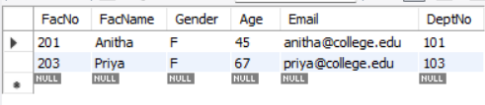

2. List all Interns working under Faculty No. 201
SELECT *
FROM INTERN
WHERE FacNo = 201;
SELECT *
FROM INTERN

OUTPUT:
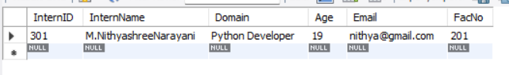

3. Display Faculty whose Age is less than 60
SELECT *
FROM FACULTY
WHERE Age < 60;
SELECT * FROM FACULTY;
OUTPUT:
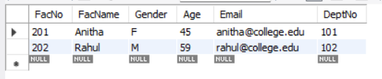

LIKE Clause
4. List Interns whose name ends with "ya”

SELECT *
FROM INTERN
WHERE InternName LIKE '%ya';
OUTPUT:
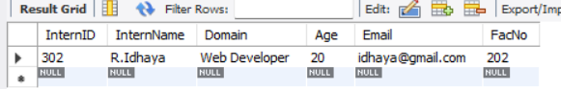

5. Display Interns whose name contains "th"
SELECT *
FROM INTERN
WHERE InternName LIKE '%th%';OUTPUT:
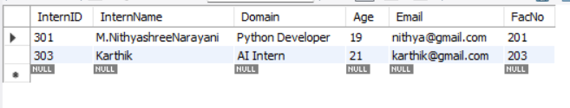

6. Display Interns whose names do not contain exactly six letters
SELECT *
FROM INTERN
WHERE InternName NOT LIKE '______';
OUTPUT:
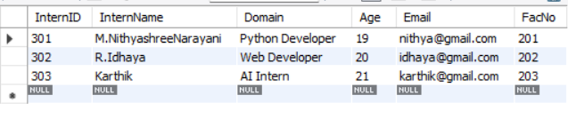

7.Display Faculty whose names contain "ra"
SELECT *
FROM FACULTY
WHERE FacName LIKE '%ra%';
OUTPUT:
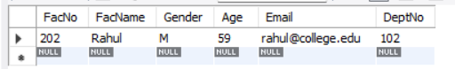

RESULT:

The records were successfully retrieved from the tables using the SELECT statement with WHERE clause and LIKE operator.

